**PSOG Cisco SPARK BOT**

**Usage :**

**IMPORTANT : Please add the Cisco spark bot into your group or direct Spark Spaces by adding this PSOG-bot id :** [**psog@sparkbot.io**](mailto:psog@sparkbot.io) **to your Cisco Spark Space.**

1. *Group room vs Direct room*

In a group room, you need to call the bot by its mention and name before asking for help or typing commands (<https://support.ciscospark.com/customer/en/portal/articles/2723799-get-someone-s-attention-with-mentions)>

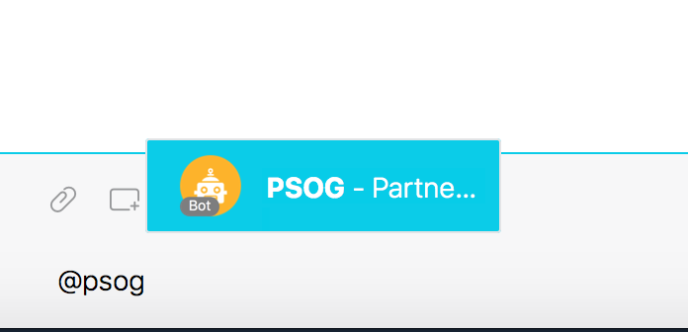

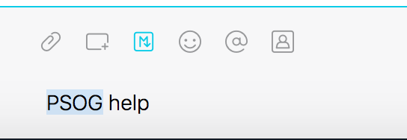

In a 1:1 direct room, you can directly ask the bot for help

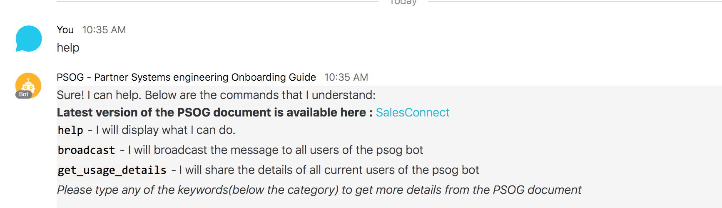

1. *Topic search*

From the help screen, you can see the list of topics supported – arranged under categories as shown below

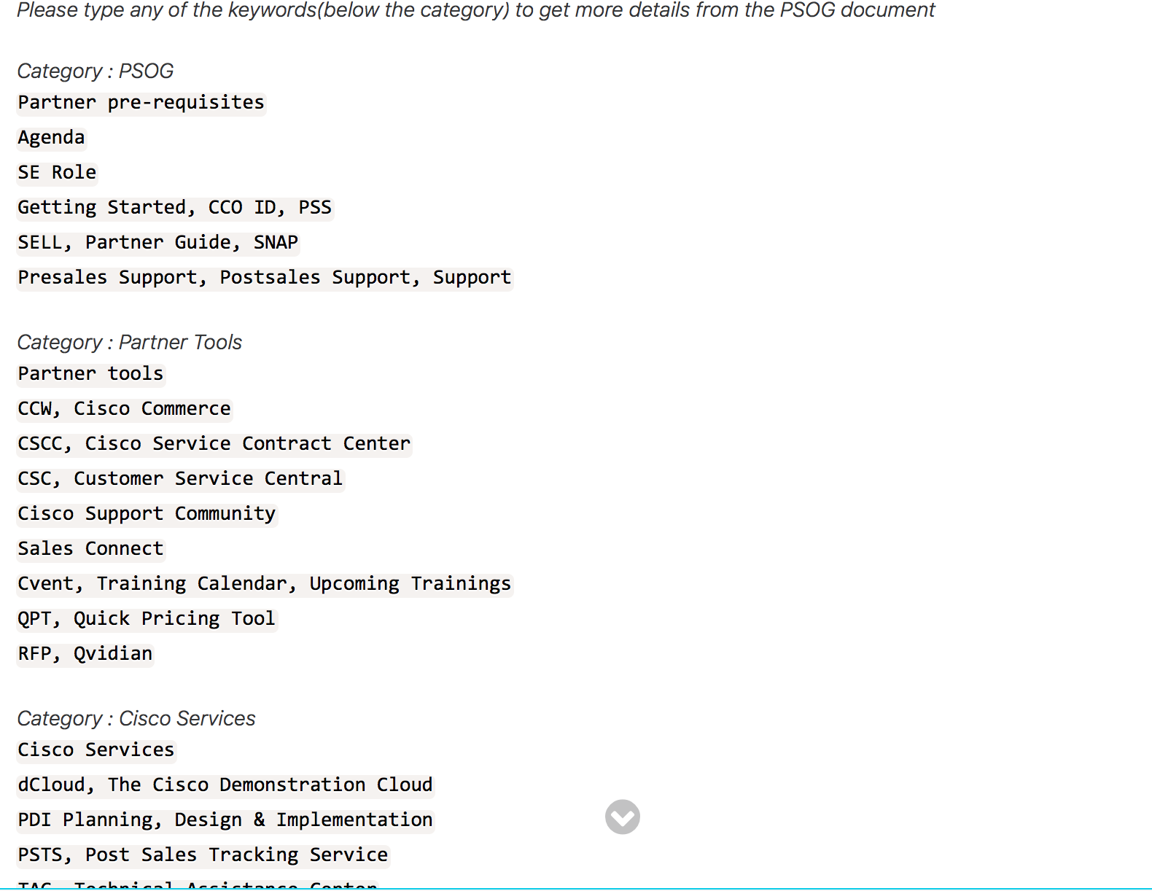

You can then select any topics listed under the category to get more details around it. Eg in a 1:1 room, you can type the following and see the output

